Twitter registration

Created July 06, 2018.

To register the application, you must:

1. Go to <https://apps.twitter.com/>.
2. On the page that opens, click on the "Sign in".

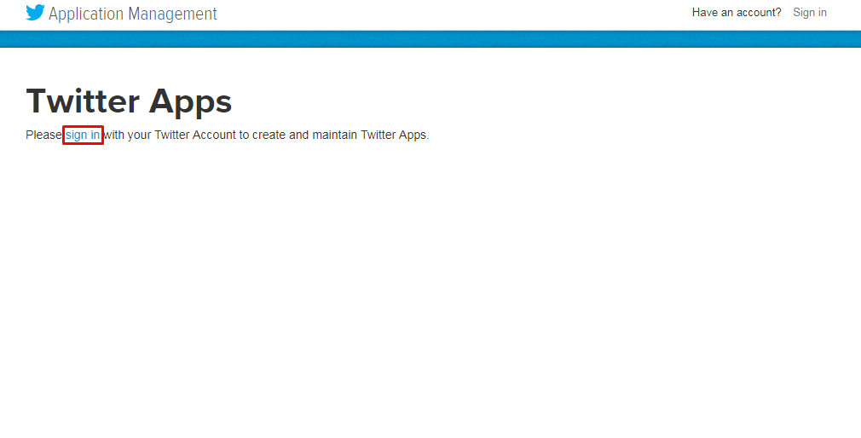

3. Enter your credentials and click on the "Log in".

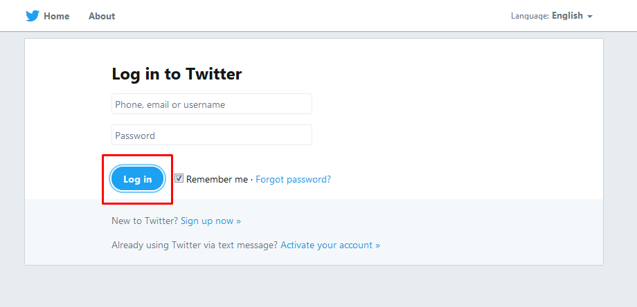

4. On the Twitter Apps page, click on the "Create New App" button.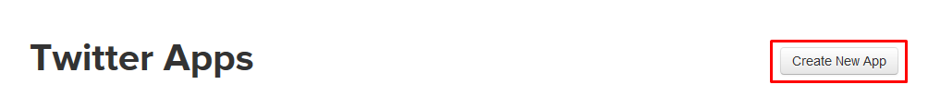

5. On the Create an application page, fill in the required data, agree with the developer license agreement and click on the "Developer Agreement" button. Also do not forget to specify the Callback URLs to which the necessary keys for the API call will be returned.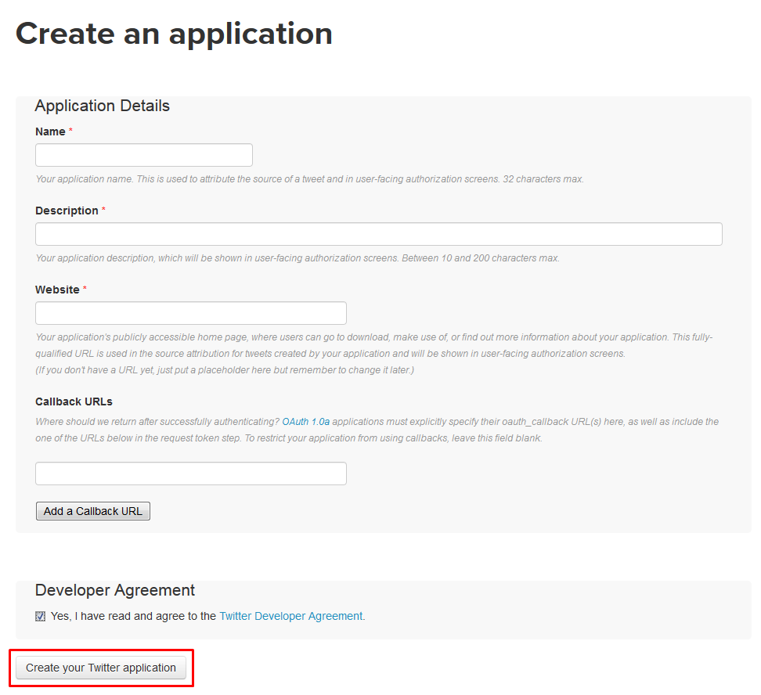

6. On the Keys and Access Tokens tab, click the modify app permissions link.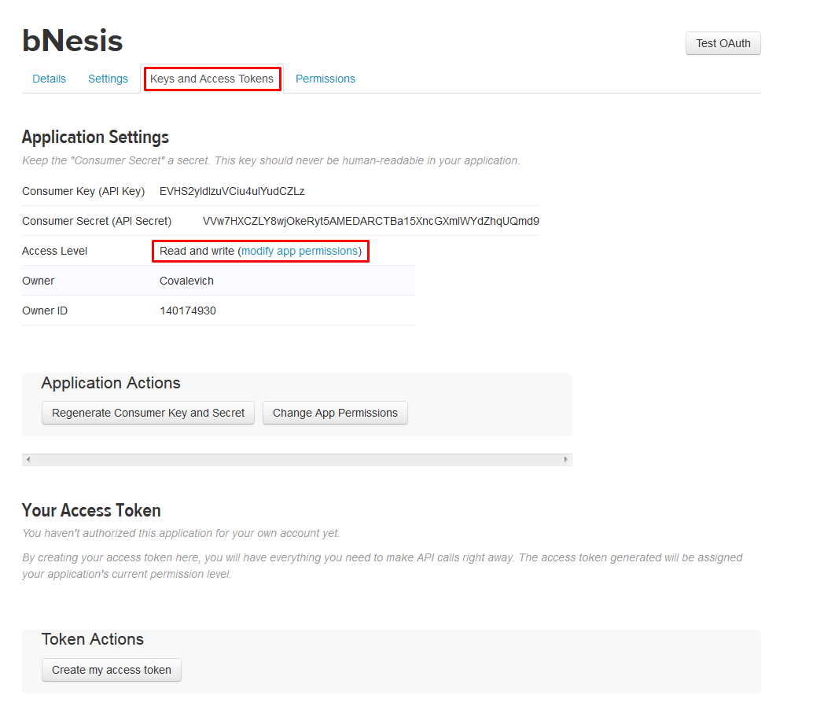

7. Specify the type of access to the Read, Write and Access direct messages application and click the Update Settings button.

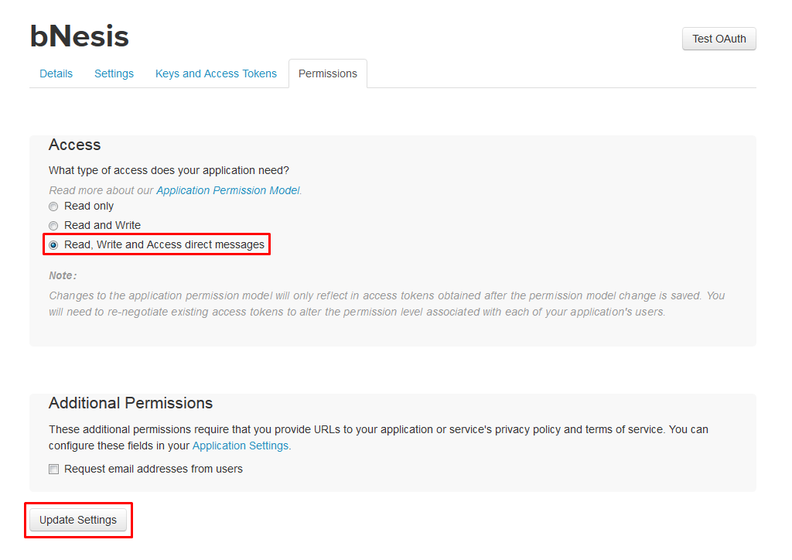

8. Now you can use the "Consumer Key" and "Consumer Secret" on the "Keys and Access Tokens" page for authorization in the service.

